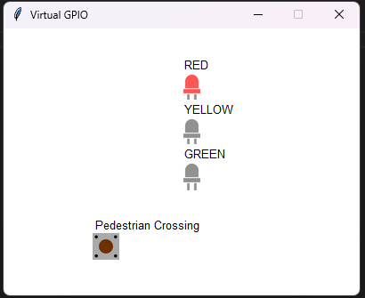
traffic_light_sim.py
from tkgpio import TkCircuit

configuration = {
"width": 400,
"height": 300,
"leds": [
{"x": 200, "y": 50, "name": "RED", "pin": 17},
{"x": 200, "y": 100, "name": "YELLOW", "pin": 27},
{"x": 200, "y": 150, "name": "GREEN", "pin": 22}
],
"buttons": [
{"x": 100, "y": 230, "name": "Pedestrian Crossing", "pin": 11}
],
"title": "Traffic Light Simulation"
}

circuit = TkCircuit(configuration)

@circuit.run
def main():
import traffic_light

if __name__ == "__main__":
print("Starting Traffic Light Simulation...")

traffic_light_sim.py
from gpiozero import LED, Button
from time import sleep

red_light = LED(17)
yellow_light = LED(27)
green_light = LED(22)

pedestrian_button = Button(11)

# initial
red_light.on()
yellow_light.off()
green_light.off()

auto_mode = True
red_time = 5
yellow_time = 2
green_time = 5
pedestrian_requested = False

def pedestrian_crossing_request():
global pedestrian_requested
print("Pedestrian requested to cross!")
pedestrian_requested = True

# กดปุ่ม
pedestrian_button.when_pressed = pedestrian_crossing_request

def traffic_light_sequence():
global pedestrian_requested

while True:
# ไฟแดง
red_light.on()
yellow_light.off()
green_light.off()
print("Red light: Stop")
sleep(red_time)

# ไม่กด
if auto_mode or pedestrian_requested:
# ไฟเขียว
red_light.off()
yellow_light.off()
green_light.on()
print("Green light: Go")
sleep(green_time)

# ไฟเหลือง
red_light.off()
yellow_light.on()
green_light.off()
print("Yellow light: Prepare to stop")
sleep(yellow_time)

pedestrian_requested = False

try:
traffic_light_sequence()
except KeyboardInterrupt:
red_light.off()
yellow_light.off()
green_light.off()
print("\nTraffic light simulation stopped")

